# INTRODUCTION

# An ATS creates opportunities to automate manual processes, increase visibility into the hiring cycle for the entire recruiting team, and increase opportunities for communication throughout the candidate journey. 78% of recruiters using an ATS report that it has improved the quality of the candidates they hire.

1. **Problem Definition & Design Thinking**
   1. Empathy Map
   2. 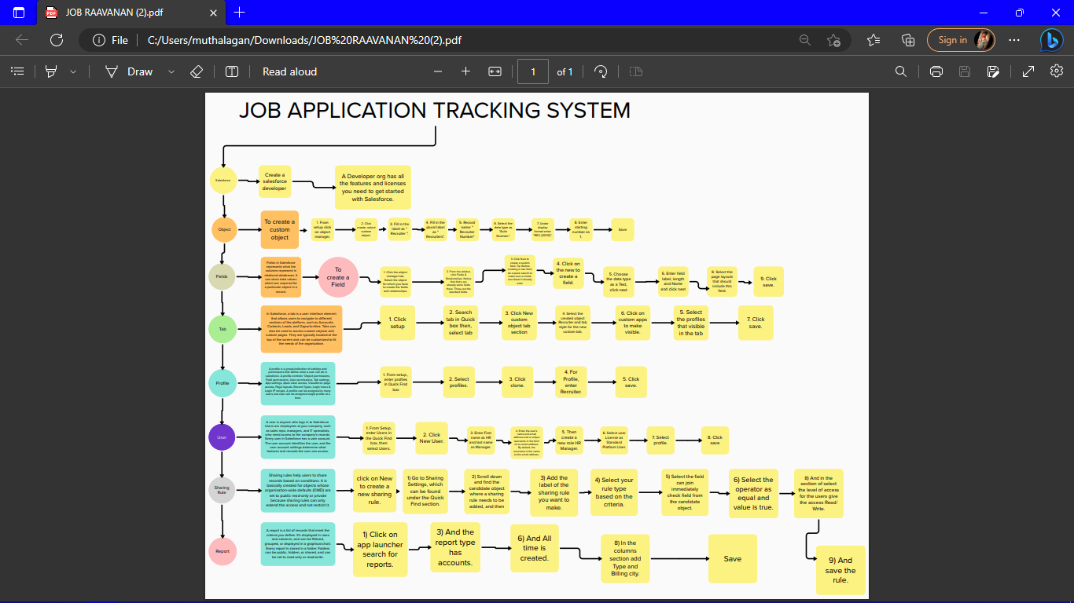
   3. Ideation & Brainstorming Map
   4. 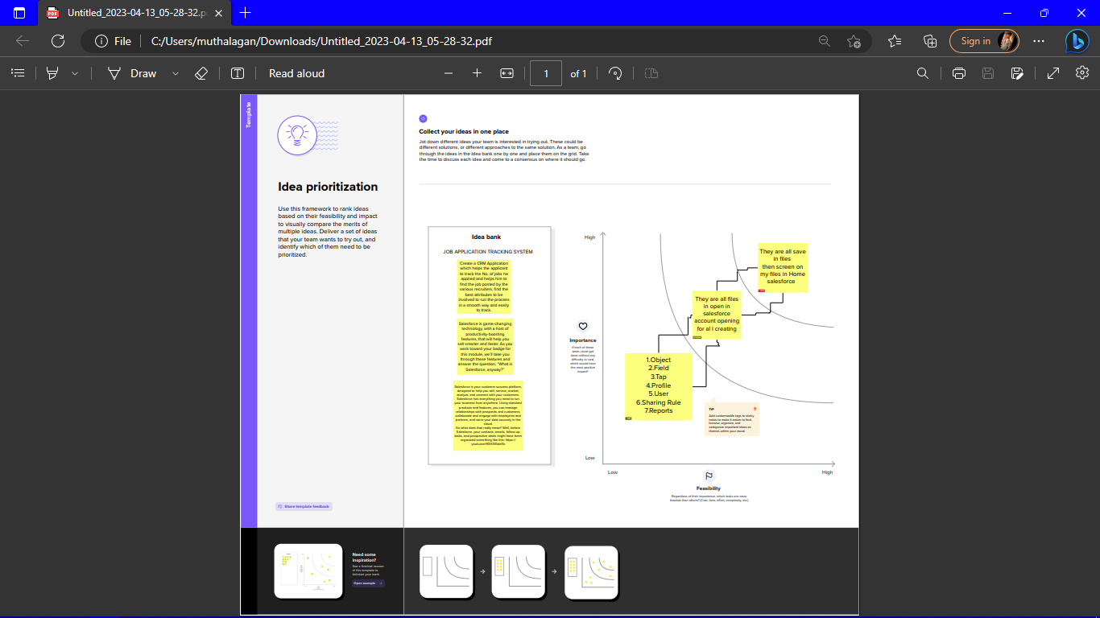

# RESULT

* 1. Data Model:

|  |  |
| --- | --- |
| Field label | Data type |
| dharnish | Custom Field Definition |
| Job creater | Custom Field Definition |

|  |  |
| --- | --- |
| **Object name** | **Fields in the Object** |
| obj1 |  |
| obj2 |  |

# Activity & Screenshot

|  |  |
| --- | --- |
| Field label | Data type |
| Recruiters | Custom Field Definition |
| candidate | Custom Field Definition |

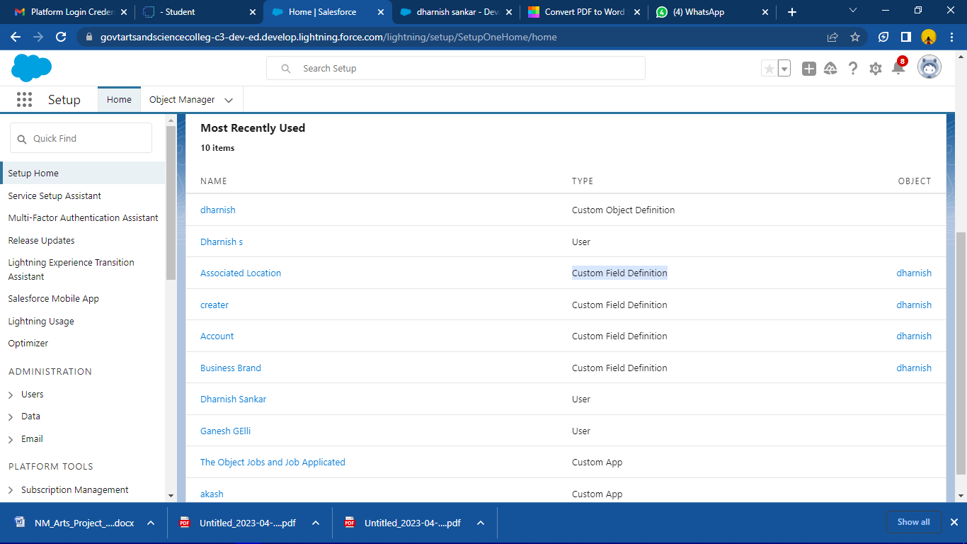

# Trailhead Profile Public URL

**Team Lead** [**https://trailblazer.me/id/dsankar22**](https://trailblazer.me/id/dsankar22)

**Team Member 1 -**[**https://trailblazer.me/id/dsankar22**](https://trailblazer.me/id/dsankar22)

**Team Member 2-**

<https://trailblazer.me/id/brevannanlakshmi>

**Team Member 3 -** <https://trailblazer.me/id/brevannanlakshmi>

1. **ADVANTAGES & DISADVANTAGE**

Recruiters often succeed because of their people skills. If ATS software can give them more time to connect with real people, they will be more successful at placing candidates.

This is an advantage because you are not limited to current job seekers. Some of the best talent may have no idea that you could have an even better opportunity available than the one for which they previously applied.

Wealth of Data

In addition to selecting the right job applicants, an ATS can collect data to improve the overall recruiting process. It can keep track of the best sources of applicants and track the time it takes to complete the placement process.This way, you can analyze your time commitments and see if your valuable time could be invested in another task.

# APPLICATIONS

# 

# Better candidate experience through faster scheduling and communication – especially in remote and hybrid work environments

# Access to multiple job boards and the ability to manage all applications in a centralized location

# Improved employer brand that attracts great candidates

# Valuable metrics and reports to improve the hiring process (e.g. HR analytics)

# Easier compliance with laws related to recruitment

# CONCLUSION

Applicant Tracking System for recruiters is a very effective hiring solution that most of the successful recruiters utilize. Because without it, there is a good chance that your process of moving applicants through different stages can become very difficult.

# FUTURE SCOPE

The world knows that Applicant Tracking Systems (ATS) made their way into the recruitment domain just a few years ago. Although, previously, ATS solutions were implemented only by a few companies that could bear the heavy investment costs, now their use in the HR arena has risen to a great extent. According to a recently released survey report, the majority of staffing firms worldwide will opt for an Applicant Tracking System by the end of 2020 to improve the overall talent acquisition efficacy, in this scope the future of ATS definitely looks bright